God Saw That It Was Good

Inspiring Discipleship for the age
of Climate Change
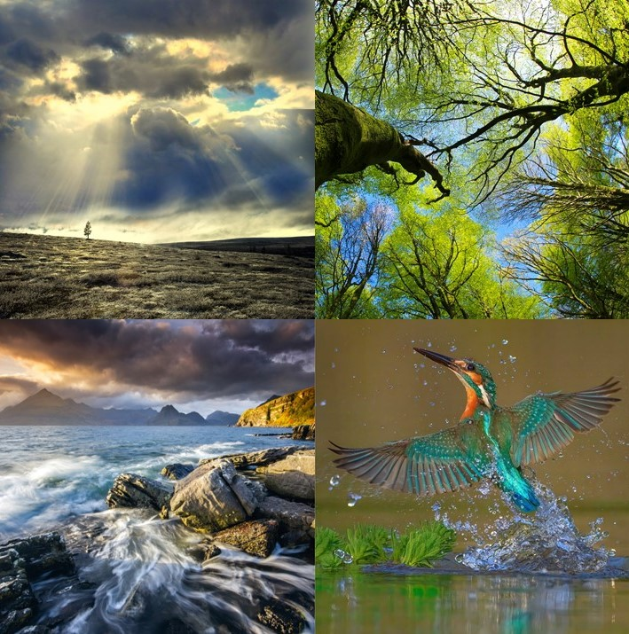
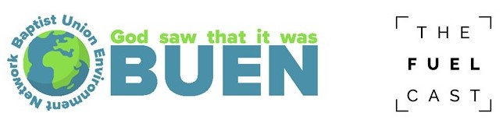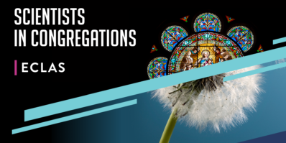
“my ears have heard of you but now my eyes have seen you.”
(Job 42v5)
Introduction
Popular science and natural history presentations on TV and the Web, use stunning visual imagery to draw people towards an appreciation of the wonder of creation and sciences understanding of it. In such a visual age, “God saw that it was good” aims to take people on a further step of encounter. Beyond the wondering of the “how” and “why” of sciences exploration of the world, towards an encounter with the God of creation through the visual senses. Inspiring people to join with Job, as he responded to God’s wonderous tour of creation, saying “my ears have heard of you but now my eyes have seen you.” (Job 42v5)
Christians believe that God created the world, and gave humanity the responsibility to share in God’s nurture of it. Yet, in an age when climate change due to human activity is reshaping the planet, impacting society and lives, as well as all life that makes up the whole of God’s community of creation, perhaps we have forgotten how to look. Really look. To appreciate the goodness and wonder of what God has made. And to catch a glimpse of the wonder of the creator through what God has made.
“God Saw That It Was Good” is a new resource from BUEN – the Baptist Union Environment Network. It aims to inspire a new way of looking at the world around us and shape our missional discipleship in an age of the climate and environmental crisis affecting people and the whole community of creation now and into the future. A large photographic installation with images speaking of themes of sky, coasts, trees, and life echos the stunning visual imagery of popular nature documentries. Drawing upon scientific and faith persepctives around these key environmental themes, accompanying audio reflections on YouTube - accessible on mobile phones - enhance the visual encounter. Exploring divine creativity and wonder, the God’s creative playfulness in the unimaginable diversity of creation together with the inter-connectivity of creation and the Spirit drawing all things back towards the love of God.
Listening and seeing, as with Job, suggesting a way of encountering creation both scientifically and with the eye of faith. Engaging the heart as well as the head, the display seeks to re-enchant people’s perception of the world around them. Recognising its value in connecting them with the divine shaper of creation, inspiring practical action as to how walk more softly with God among his creation in an age of climate and environmental change, so sharing more fully day by day in God’s Mission to the whole of creation.
For further background on the vision of the display

See page 28 of the Summer 2022 edition of Baptist Together Magazine – “God Saw That It Was Good” by Dave Gregory
https://baptisttimes.co.uk/Publisher/File.aspx?ID=308772&view=browser

Watch a recording of Dave Gregory speaking on “Visual Eco-Theology : Seeking the Divine Through Nature Imagery” recorded at the British & Irish Association for Practical Theology Conference in July 2021 ADD YouTube Link
Images and Reflections

Launched at the Baptist Assembly in 2022, “God Saw That It Was Good” features four images linked to environmental themes – coasts, sky, life, and trees. Each of the images is accompanied by an audio reflection shaped around the themes of wonder of creation and creator, the playful creativity of God seen in the astounding diversity of creation and the interconnectedness of creation and Holy Spirit drawing all things towards the love of the creator. The reflections can be found on YouTube, with each being read by their author;

Coasts – Dave Gregory, Baptist Missioner for Science and Environment
Sky – Dave Gregory, Baptist Missioner for Science and Environment
Life – Geoff Colmer, Baptist Union President 2021-22
Trees – Laura-Lee Lovering, BMS World Mission Creation Steward Co-ordinator

Links to the YouTube files of the reflections can be found via on the “God Saw That It Was Good” page of the BUEN section of the Baptist Union website;
https://www.baptist.org.uk/Groups/377482/God_saw_that.aspx

There are also written copies of the reflections which can be downloaded from the page together with accompanying discussion material for use in small groups.

The display can either be hosted as a physical or digital installation, or used digitally as part of a service, event, or small group.

Over the coming year, BUEN is working with Andy Thomas of Fuel Cast Films to make short popular science videos based upon the images. Weaving together science and theological ideas to engage with the climate and environmental crisis, this will provide further resources for small groups and larger gatherings. The videos will be available in the summer of 2023.

Inspire Missional Discipleship in an Age of Climate Change

The “God Saw That It Was Good” installation and resources can be used flexibility to inspire people to grow in their mission discipleship and appreciation of God’s invitation to share in his mission to all creation.

Churches, networks, and organisations will be aware of the context know their specific context and will be better at discerning what is needed in their setting in a creative and prayerful way. Below are a few ideas as to how the installation and resource might be used.

- In the local church, as part of an event, sermon series or church weekend focusing upon climate and environmental issues. It might be used to start the church’s environmental journey, connecting with Eco-Church. The images might provide a focus for a prayer space connecting people with God through appreciation of creation or as part of the prayer pattern of a Renew Wellbeing space. Perhaps get the children and young people who have a growing concern over the environmental and climate crisis to take the lead.

- At a conference. The installation might provide a focus at a church, regional or ministers conference, providing either a central environmental focus or a fringe activity.

- At a Theological College, as part of student engagement with Eco-Theology and Eco-Mission, or as part of a worship or prayer event.

- As part of a Community Eco-event, such as the “Great Big Green Week” initiative of the Climate Coalition, providing a distinctly Christian perspective complementing other voices.

- In a Community Space such as library or shopping centre as a pop-up event engaging passers-by.

- In partnership with a Local Authority. Many of these have declared “Climate Emergencies,” and as part of implementation are developing community campaigns to raise community awareness of our need to care for the environment.

- In collaboration with a local school. Most schools now have staff who are responsible for taking a lead on environmental matters, together with a “Eco-Team” comprised of pupils. Schools could be invited to the church to see the images or they could be offered to a school to complement their environmental curriculum. Perhaps let the schools “Eco-Team” take the lead, encouraging the development of young leaders.

Hosting the Exhibit as an Installation

Physical Installation : Using the “God Saw That It Was Good” as a physical installation has the advantage of the scale of the images drawing people into the scheme, helping to create a sense of wonder. The installation comprises of four large roll-up banners – each 2m wide by 2m high – with stunning high-definition images around themes of coasts, sky, life, and trees. There are two supporting banners with information about the display.

The banners can be used together – as in the image from the Baptist Assembly 2022 – or placed separately around a room or venue.

Visitors can either be provided with printed copies of the reflections. Or they can listen to them directly using mobile phones and devices by accessing the recordings from YouTube. If mobile phones are used, the venue will either need a Wi-Fi that is accessible to visitors or a sufficiently strong mobile signal so they can access them directly using their own mobile internet.

To ease access to the reflections, scanning a QR code on one of the supporting banners with a smartphone leads to the “God Saw That It Was Good” page;

This can be scanned using the camera app of an iPhone. For android smart phones, scan the QR code using the “Google Eye” feature of the Google search engine. Alternatively, you can install a QR-code app.

If reflections are listened to via mobile phones, it is recommended that people are encouraged to use headphones so different people can listen to different reflections at the same time. There is set of ten basic wired headphones that can be provided but for improved audio quality it is best if visitors bring their own headphone. Alternatively, the reflections might be played over the venues audio system

Digitally Installation : The exhibit can be also used digitally. The mp4 files on YouTube include both the images and reflection. They could be displayed using multiple video projectors in the same or different spaces with the reflections being played over a speaker or PA system.
If only a single space is available, then the YouTube video could be projected onto a large screen. Reflections can be played over a PA system, listened to individually via mobile phones or individually read using the written copies. The sequence of videos could be repeated over time.

Alternatively, the individual images are also available on the “God Saw That It Was Good” page. There could be downloaded and displayed using a video projector with people reading or listening the reflections via YouTube.

Using the Installation with Small Groups and in Worship

Small Groups : The YouTube videos would be used as the focus for small groups. Videos could be watched on a Smart TV or computer direct from YouTube, or pre-downloaded. There is supporting material, including discussion starters and prayer suggestions downloadable from the “God Saw that It Was Good” page.

Worship : The video could also be played in a worship service, either to inspire prayer or to complement a sermon series on environmental topics. Again, some suggestions can be found on the “God Saw That It Was Good” website.

Video : For the future, BUEN is working with Andy Thomas of Fuel Cast Films to make short popular science videos based upon the images. Weaving together science and theological ideas to engage with the climate and environmental crisis, this will provide further resources for small groups and larger gatherings. They will be available in the summer of 2023.

Practical Arrangements – Physical Installation

Booking - To book the display, please complete the form on the “God Saw That It Was Good” webpage. Timeslots for booking need to be at least a two-week period to allow time for transportation. Completed forms should be returned to BUEnvNet@outlook.com

Transportation – The roll-up banners are packaged in five 2m x 15cm x 15cm boxes, each weighing 8kg.

There are several transportation options

- Pick-up and return - in person from their storage location in Newport Pagnell, Milton Keynes. Please ensure the vehicle is large enough to fit the banners in without affecting visibility or hindering the driver. The cost of transport is covered by the hosting church or organisation.

- Delivered by BUEN – If you would like a speaker from the BUEN network to be part of your event, it may be possible for them to bring the banners with them to your event. The hosting church would need to cover the cost of travel and transporting banners from and back to their storage location in Newport Pagnell. If the banners are required for longer than the BUEN speaker is present, the host church is responsible for return transport. The host would also need to cover any accommodation costs.

- Commercial Courier – The boxes can be couriered to the host venue using a commercial company. Both outward and return costs need to be covered by the church. Outward transport will be arranged by the project lead, Dave Gregory, the host return delivery. Prices vary but for one-way transport the cost is around £125. Website such as https://www.parcelhero.com/ or https://www.parcel2go.com/ can provide prices for services across different carriers. Several churches with a region might together use the banners over several weeks, the cost of transport to the region being shared with transport between venues being undertaken by the hosts.

Costs for these different options are summarised in the “Cost” section below.

Practical Arrangements – Digital Installation

Hosts will be responsible for downloading material or having Wi-Fi to access the images and reflections on YouTube. These can be downloaded from YouTube using a variety of different apps available on app stores. Screens, IT, and multi-media equipment need to be provided by the host.

Consultancy and Training

To help hosts get the most out of the material and your event, Dave Gregory, Baptist Missioner for Science and Environment and one of the leads for the “God Saw That It Was Good,” offers Zoom consultancy and training sessions for one or two hours for each hosting organisation or event. These are charged at £25 pounds per hour, but funding from “Scientists in Congregations” means that we can offer the first free hour free.

Dave is an experience science and faith communicator and will provide an assessable update on the science of the climate and environmental crisis, cover questions and objections that might be raised and share how the material will help people to grow in their awareness of God’s gift of creation and how in their discipleship they may share more fully in God’s mission to care for the whole of creation.
Costs

Transport – The hosting church or organisation is responsible for the cost of transport to and from the venue.

Gift - We would be grateful if hosts could provide a gift towards BUENs work across the Baptist Together network. A suggested level would be £150 per event. However, if this is too large, then please speak with Dave Gregory as we would not wish finance to be a barrier to the material being used to encourage the life and mission of the church.

Speaking Fee – If you invite a member of the BUEN community to be part of your event, please consider giving a speaking fee alongside covering travel and accommodation costs.

A summary of costs is provided in the table below

Transportation | Variable depending upon mode of transport  If using commercial carriers around £250 for return transport  Milage at £0.45p/mile if transported by BUEN
Gift to BUEN | Suggested level is £150 for the physical installation  Suggested level is £50 for the digital installation  But please give what you are able
Speakers Fee and Costs | Suggested speakers fee of £150 but please give what you are able.  Costs of travel/overnight accommodation if needed
Zoom Consultancy and Training | £25/hour, but first hour provided free  1-, 2- or 3-hour sessions possible

Acknowledgements
BUEN is grateful for the generous support of The John Ray Initiative and Baptist Insurrance in producing the installation. The project is also supported by the Scientists in Congregation project, part of the Equipping Christian Leadrs in An Age of Science programme run by Durham and York Universities. BUEN is also thankful for the continued support and encouragement of the Faith and Society Team at the Baptist Together National Resource.
The development of the installation was led by Rev Dr Dave Gregory, Baptist Mission for Science and Environment and Rev James Watterson, lead of the BUEN Hub of the Baptist Together North Western Region

